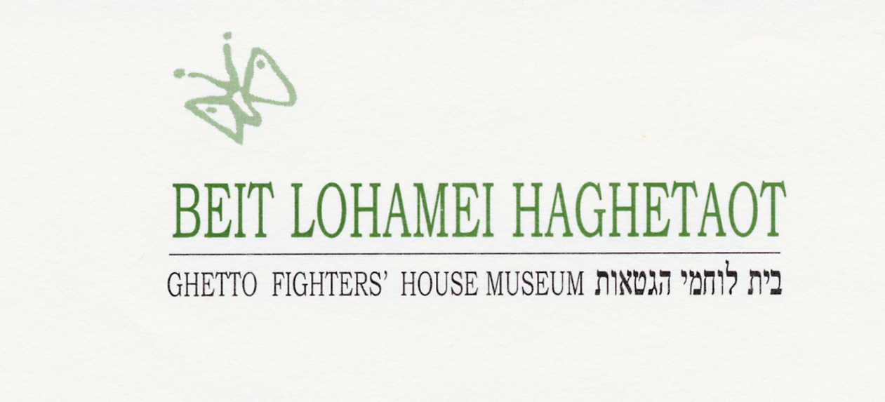
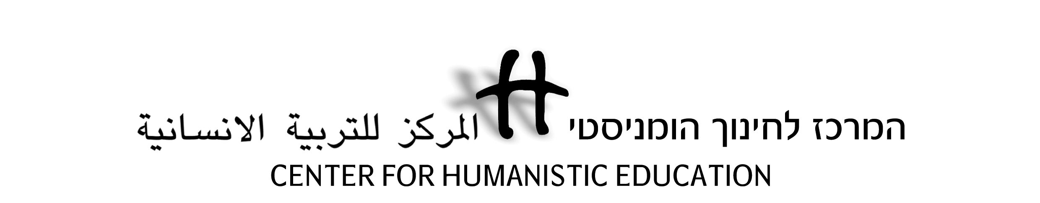
Holocaust Education for Democratic Values
CHE-Erinnern.at Seminar at Ghetto Fighters House, July 2016

Day 1, 17/7: Introducing Ghetto Fighters House Museum

Time | Subject and Activity Description | Goals | Comments
9.00-9.30 | Seminar opening, introduction |  | At the Center
9.30-12.00 | Lochamei Hagetaot (the Ghetto Fighters): The story of the kibbutz and the museum.  With: Tali Shner, a scholar, pedagogue, daughter of Kibbbutz founders. | Acquaintance with the place and its unique story. | a guided tour through the kibbutz, concluding in the Witness Hall at the museum.
12.00-13.00 | Lunch
13.00-15.00 | Educational work at the museum - pedagogical and practical problems and solutions. | Acquaintance with issues of museum-based pedagogy | Discussion combined with demonstrations on the museum floor
15.00-17.00 | Personal museum time | Equipped with personal audioguides and assisted by the staff, an opportunity to visit the museum. | Educational kits will be on display in the library (sorry – only in English…)

Day 2, 18/7: Holocaust Education and Democratic Values

Time | Subject and Activity Description | Goals | Comments
8.30-10.00 | Materials of Memory: Acquaintance with the GFH Archive | Presentation and active research | Yizkor Hall,  study-room
10.00-10.15 | Break
10.15-12.00 | 1) Lessons of the Holocaust:  A text-based activity on meanings and implications of the Holocaust for us today.  2) Presentation on CHE | The activity encourages a personal and social reflective discussion on the Holocaust.  Description of the work of CHE and its particular features.
12.00-13.00 | Lunch
13.00-14.00 | "Brainland": A workshop about social discrimination | A simulation dealing with the ethical premise of human equality, in association with the Nazi racial theory.
14.00-15.30 | Exclusion of those who are 'different'  A workshop depicting the Nazi policy towards 'unwanted elements' in society. | The social and political concept of Ingroup and Outgroup: do we identify it in our own society? How can we deal with it? | Activity followed by reflective discussion
15.30-  16.00 | "Wasted Lives": genocide in the 20th century | A short film and follow-up discussion on connecting Holocaust to other genocides
16.00-16.30 | Day's closure discussion

Day 3, 19/7: Jewish-Arab Dialogue at CHE

Time | Subject and Activity Description | Goals | Comments
8.30 –  10.00 | Workshop: Majority-Minority Relations | Examination of various patterns of group-relations – from alienation to dialogue, connected to concrete contexts. | Activity followed by reflective discussion
10.00-10.15 | Break
10.15 –  11.30 | Local Context: Historical and sociopolitical background of Jewish-Arab dialogue at CHE | Deepen understanding of the major issues dividing Jews and Arabs. | Hands-on and informal confrontation with local past and present
11.30-11.45 | Break
11.45-12.30 | Presenting the Narrative-based Dialogue | Exposure to the particular approach to inter-group dialogue practiced at CHE
12.30 –  13.30 | Lunch
13.30 –  15.30 | CHE's educational operation: from theory to practice | Free discussion with CHE graduates about their experience and insights
15.30-15.45 | Break
15.45 –  17.00 | Conclusions.  Farewell!!! | 1) Comments and recommendations for next seminars.  2) What do I take with me from here?

